RICH DIALOGS
IN
IVYCOMMONS PROJECT

Document title: IvyCommons – RICH DIALOGS IN IVYCOMMONS PROJECT
Document description: list out all existing rich dialogs in IvyCommons project Version 5.0
Ivy project version information:
    - Version: 5.0.3 (Rothorn)
    - Revision: 43404
    - Build date: August 2, 2013
Author: Nguyen Thuy Hang
Document created date: 19 June 2014

Table of Contents
I. Common Dialogs 3
1.Error detail dialog 3
2.Error dialog 3
3.Login dialog 3
4.Message dialog 4
5.Question dialog 4
6. Single line input dialog 4
II. Common 5
1.Absence display list 5
2.Email notification setting 6
3.Header 7
4.Property editor 7
5.Server file browser 7
6.Substitute display list 8
7.Tab header bar 9
8.User absence display list 10
9.User display list 11
10.User substitute display list 12
III. Display DB 13
1.Database Configuration 13
2.Database connection parameter 14
3.Database connection tester 14
4.Database creation parameter 14

I. Common Dialogs
  - Error detail dialog
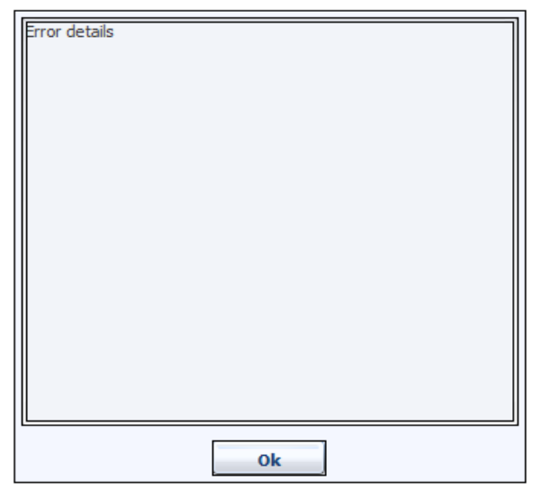
Description: Should be used to show an error message.
Dialog includes: 1 text area and OK button.

  - Error dialog
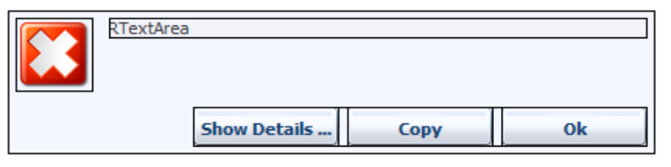
Description: Should be used to show error message with more details.
Dialog includes: 1 icon, 1 text area, Show Details button, Copy button, Ok button.
Note: when Ok button is clicked, “ Errordetaildialogpanel” will be shown.

  - Login dialog
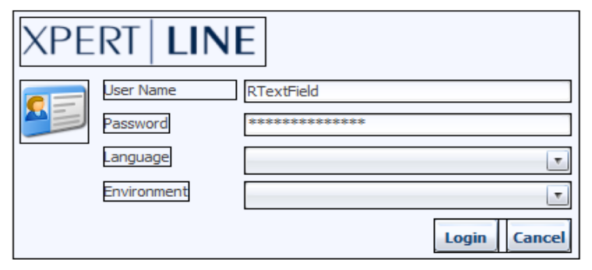
Description: Is used as a login dialog.
Dialog includes: normal information like: icon, user name, password, chosen language, environment, buttons.
  - Message dialog
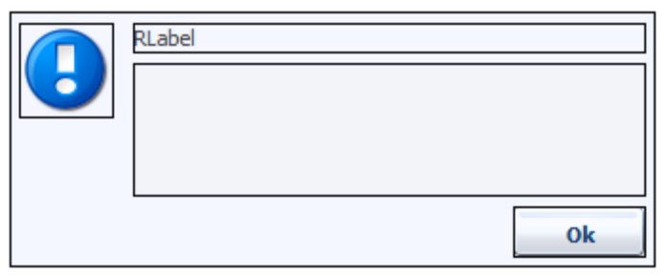
Description: This dialog should be used for displaying info message.
Dialog includes: 1 icon, 1 label, 1 text area and OK button.

  - Question dialog
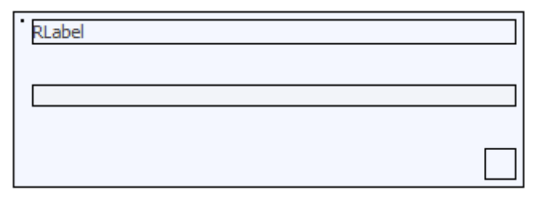
Description: This dialog should be used to display a question and some options to answer. includes 1 label, 1 text area to display question and 1 button pane where user can define their own buttons.

  - Single line input dialog
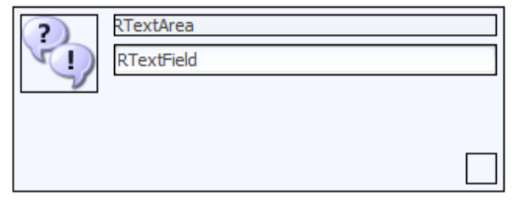
Description: This dialog could be used to show a question and get the answer from user. Dialog includes:
        - 1 text area to display question
        - 1 text field to get answer
        - 1 button pane where related buttons could be defined
        - 1 icon

II. Common
  - Absence display list
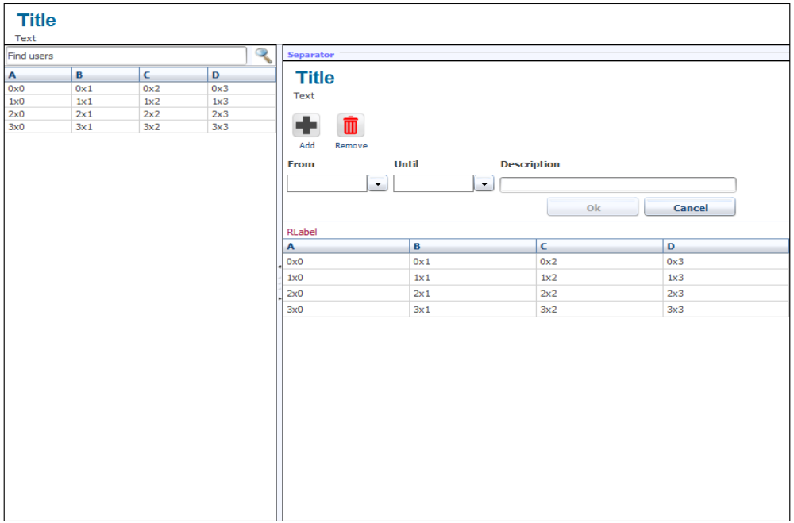
Description: This dialog is used to manage absences of users. From here user can view, add, delete absences for 1 or more people.
Dialog includes:
        - List of users (with look up text filed)
        - List of absence of each user
        - Buttons to add/delete absences
  - Email notification setting
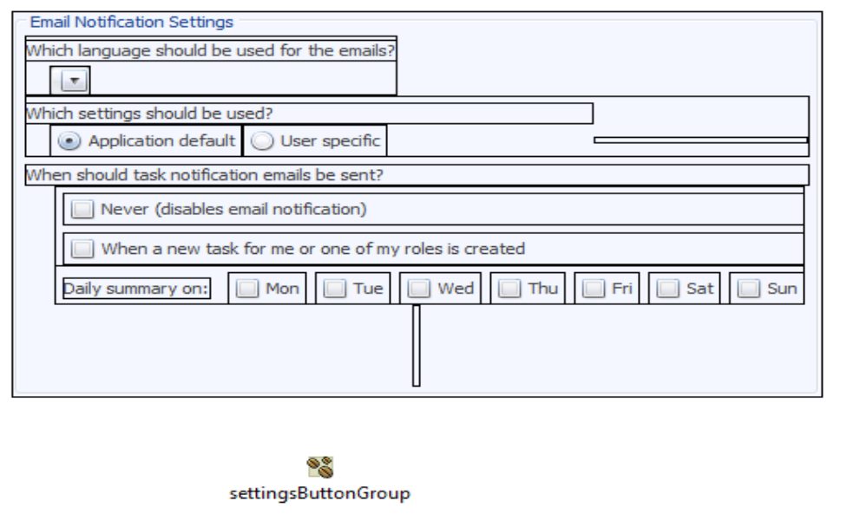
Description: This dialog is used for email notification setting.
Dialog includes:
        - Dropdown to select which language to be used in email
        - Radio button to determine sending email by Application default or User specific
        - Check boxes to disable email notification or when an email is sent
        - Check boxes to select which day to send email

  - Header
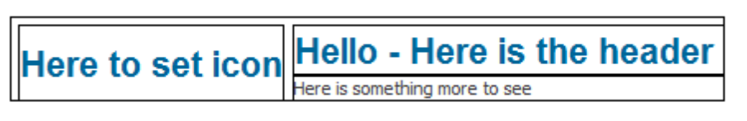
Description: This panel is used to display a header, includes icon and some header texts
Note: this is embeded in SubstituteDisplayListPanel and AbsenceDisplayListPanel

  - Property editor
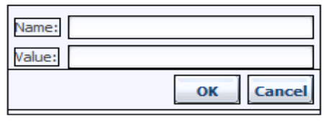
Description: This dialog is used to set value for a property (like in LDAP/Database properties)
Dialog includes:
          - Text field to enter property name
          - Text field to enter property value
          - Ok button
          - Cancel button

  - Server file browser
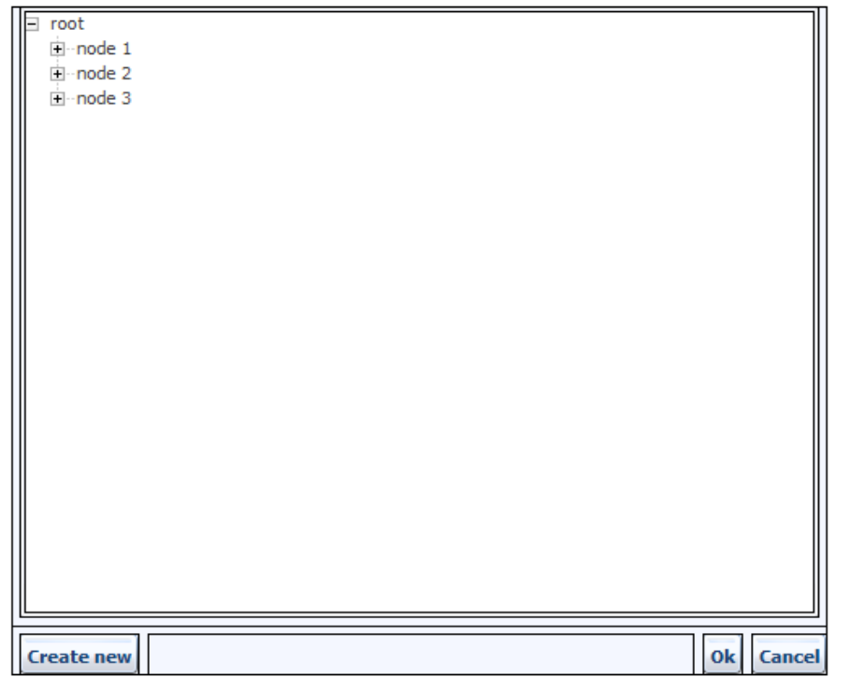
Description: this dialog is used to display a directory and support select 1 tree node from the directory. User also can create new tree node for the tree.
Dialog includes:
- Tree directory displaying
- Button/Textbox to create new tree node
- Button to select/ cancel the selection

  - Substitute display list
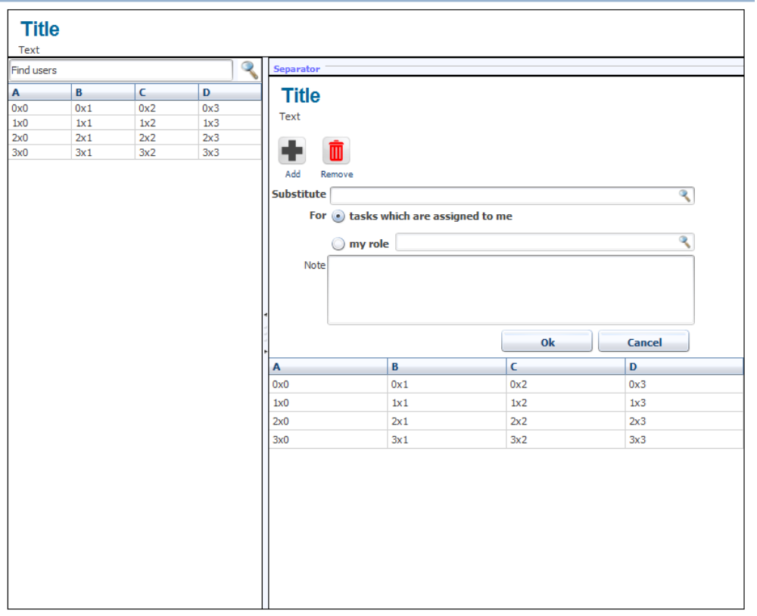
Description: This dialog is used to manage substitution of users. From here user can view, add, delete substitution for 1 or more people (delegate task to another user).
Dialog includes:
- List of users (with look up text filed)
- List of substitution of each user
- Area to add/delete substitution

  - Tab header bar
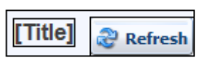
Description: This is use to display a header in an embedded tab
Dialog includes:
        - Icon
        - Label to show text
        - Refresh button to refresh data in tab.
Note: example of using this panel:
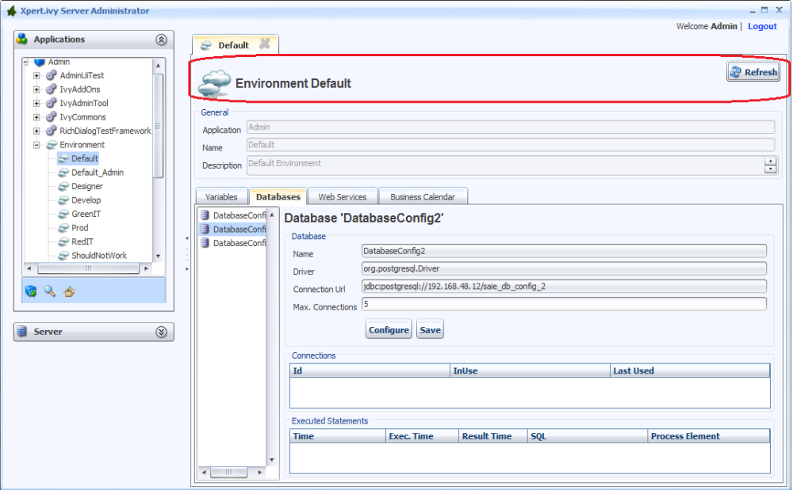

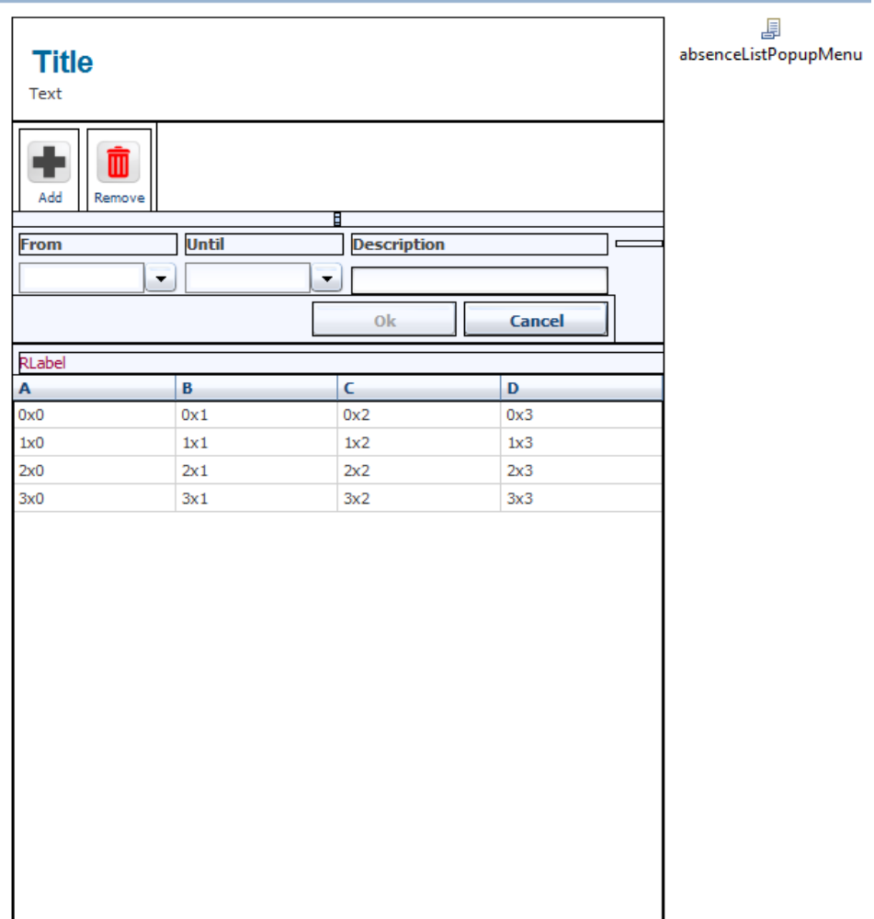
  - User absence display list

Description: This panel is used to display/add/delete absences
Dialog includes:
        - List to display absence
        - Area to add/delete absence
Note: this is used in AbsenceDisplayList

  - User display list
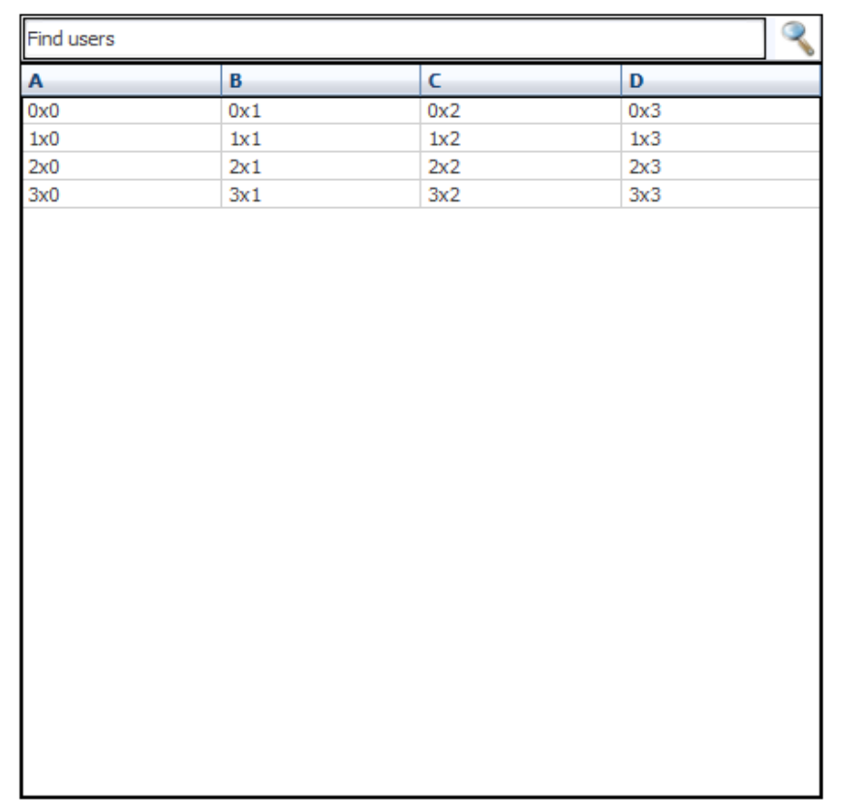
Description: This panel is used to display a list of users with look up text field
Dialog includes:
    - List to display users
    - Look up text field for users
Note: this is used in AbsenceDisplayList and SubstituteDisplayList

  - User substitute display list
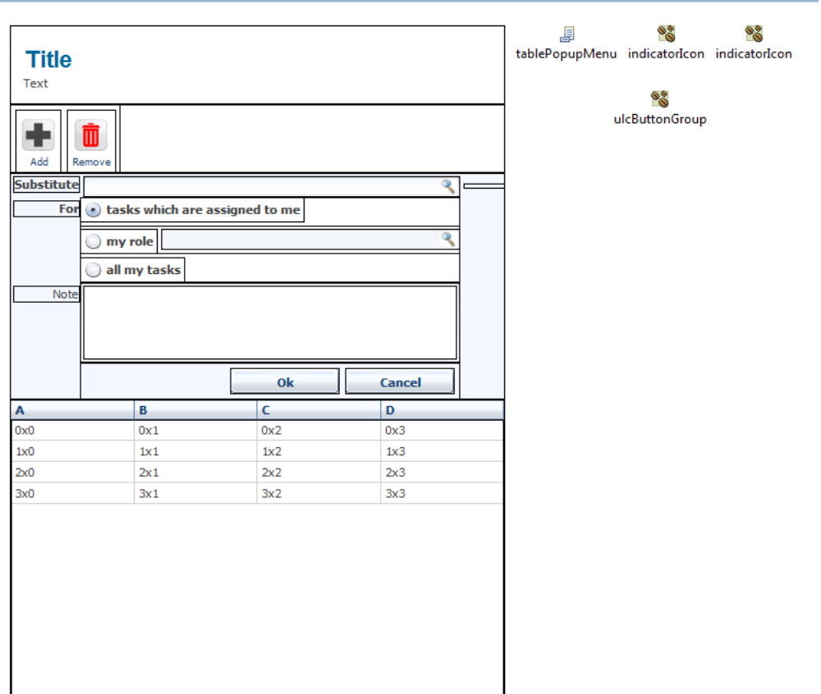
Description: This panel is used to display/add/delete substitution
Dialog includes:
    - List to display substitution
    - Area to add/delete substitution
Note: this is used in SubstituteDisplayList

III. Display DB
  - Database Configuration
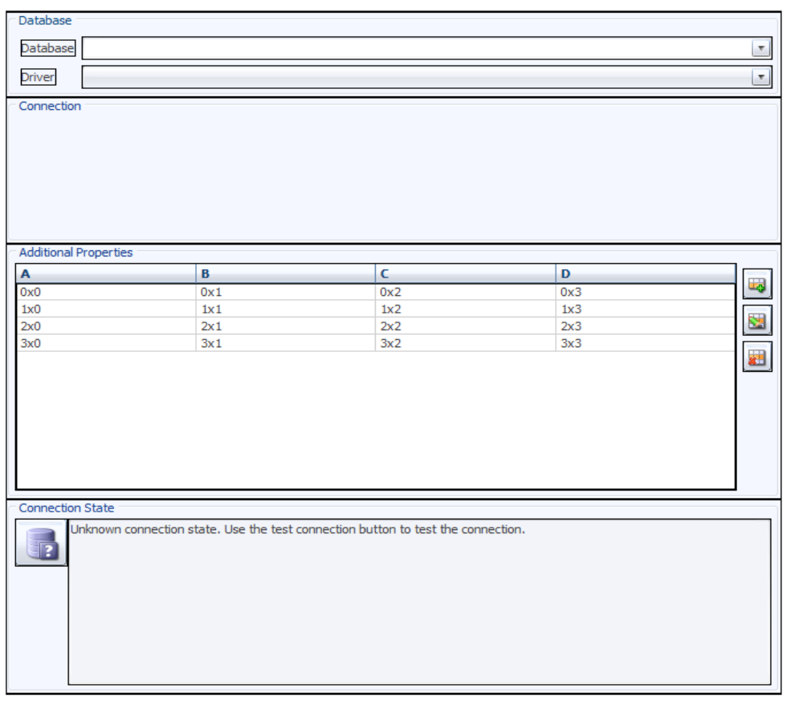

Description: This dialog is used to configure a database
Dialog includes:
    - Database dropdown: List out all kinds of DB
    - Driver dropdown: display kinds of driver
    - Connection embedded panel: where user can configure connection information of database like: host, port, DB name, user name, password.
    - Additional property list: where user can add more property for database and view all these properties in the list
    - Connection state area: where user can see the connection status of database

  - Database connection parameter
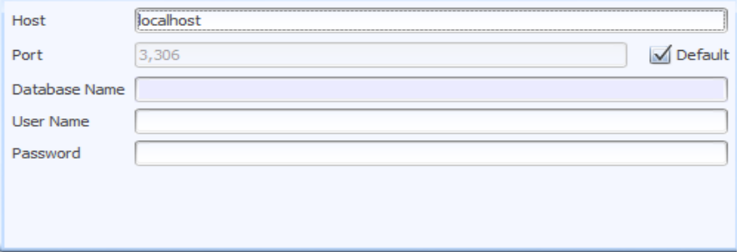
Description: This dialog is used to configure connection information of a database.
Dialog includes: In this panel, user can add connection properties like: host, port, DB name, user name, password...
Note: this is used in DatabaseConfigurationpanel

  - Database connection tester
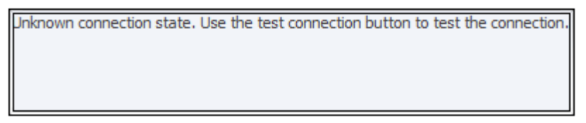
Description: This pane is used to show the connection status of database
Dialog includes: a text field to display connection status
Note: this is used in DatabaseConfigurationpanel

  - Database creation parameter
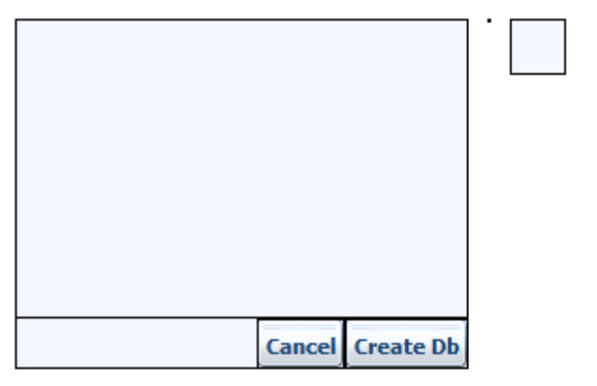
Description: this is used to input information when a database is created.
Dialog includes:
        - Connection URL text field
        - Driver Name text field
        - User Name text field
        - Password text field

